**Objectives:**

* TO LEARN BASIC LINUX COMMANDS
* TO CREATE AND MANIPULATE FILE

**LINUX BASIC COMMANDS AND THEIR OUTPUT:**

1. Command : ls

Interpretation:

List contents of the current working directory

Output:

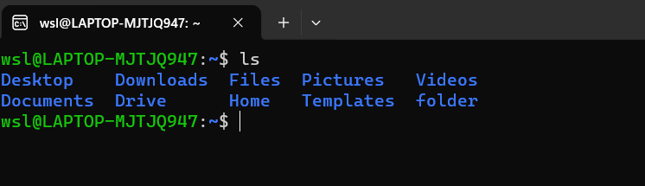

1. Command: dir

Interpretation:

List information about the FILEs (the current directory by default).

Output:

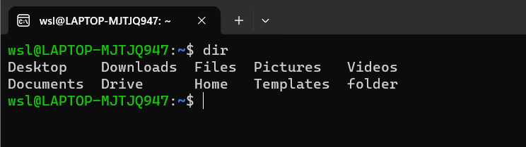

1. Command: ls -a

Interpretation:

List contents of the current working directory where option -a is used for

displaying all the contents of the directory along with entries starting with .(dot)

Output:

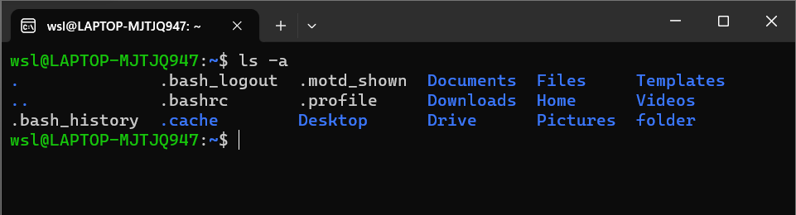

1. Command: ls -l

Interpretation:

List contents of the current working directory where option -l is used for

displaying contents of the directory with a long listing format

Output: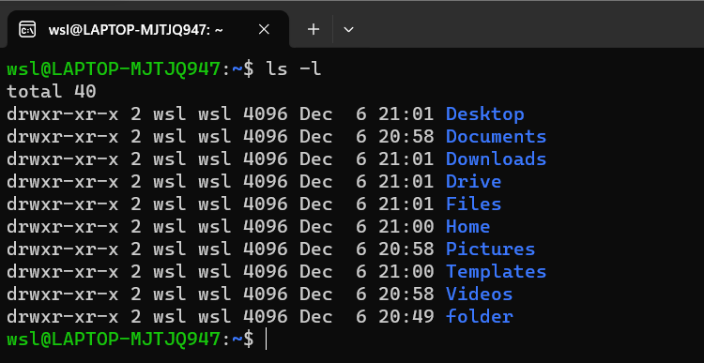

1. Command: ls –help

Interpretation:

Displays the help guide of the program ls

Output:

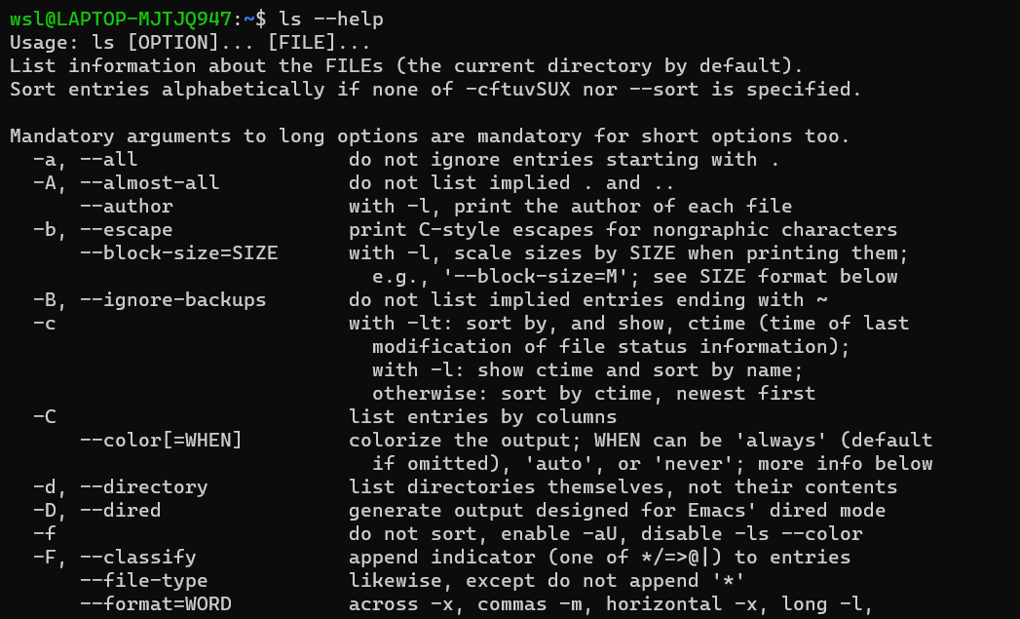

1. Command: clear

Interpretation:

Clear the terminal screen

Output:

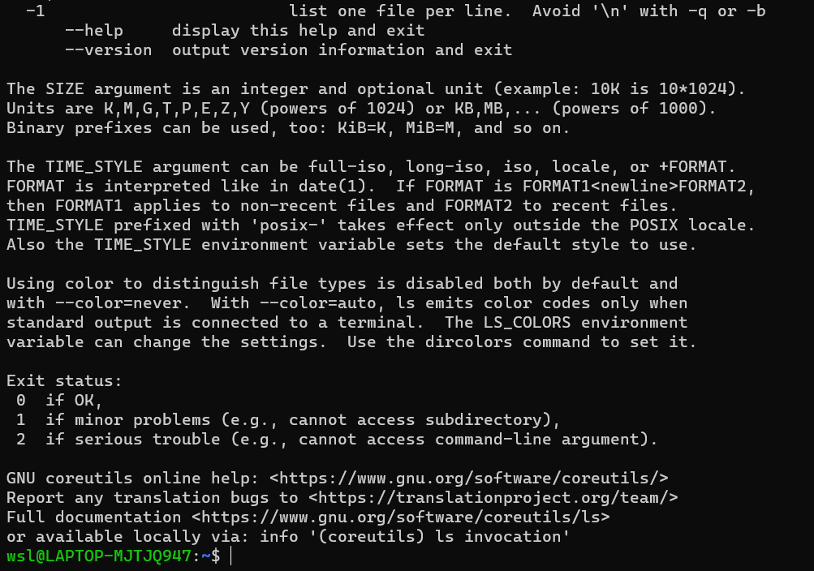

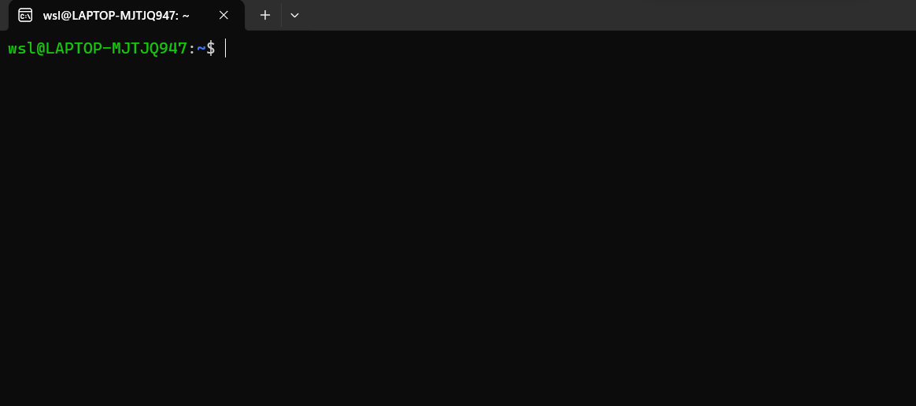

1. Command: mkdir os

Interpretation:

make directories

Output:

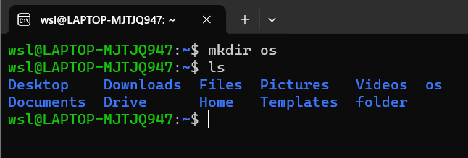

1. Command: cd os

Interpretation:

changes directory to os in terminal

Output:

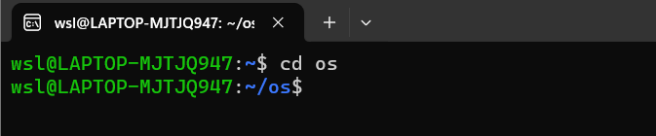

1. Command: touch linux.txt

Interpretation:

create a file named linux.txt

Output:

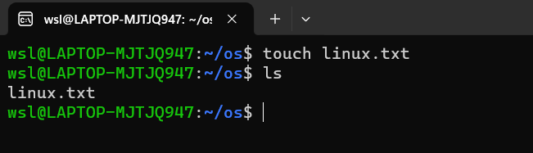

1. Command: nano linux.txt

Interpretation:

opens the file linux.txt in text editor nano

Output:

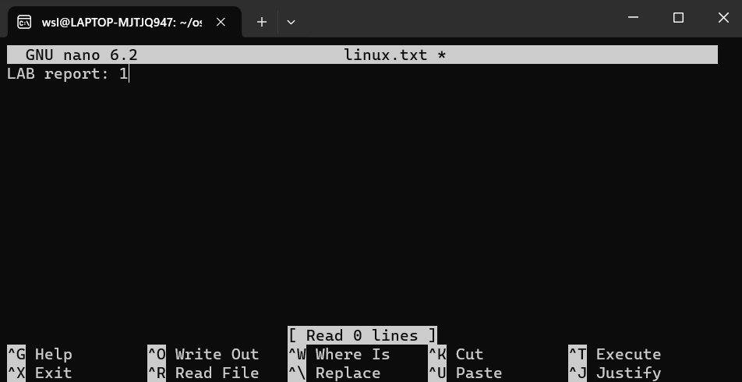

1. Command: cat linux.txt

Interpretation:

displays content of linux.txt in the terminal

Output:

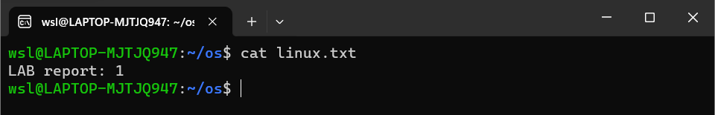

1. Command: cd ..

Interpretation:

change directory to one step back

Output:

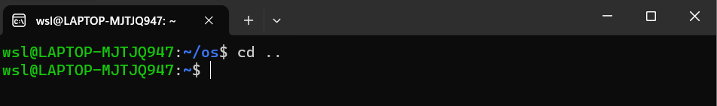

1. Command: ls –version

Interpretation:

Prints the version information the program ls

Output:

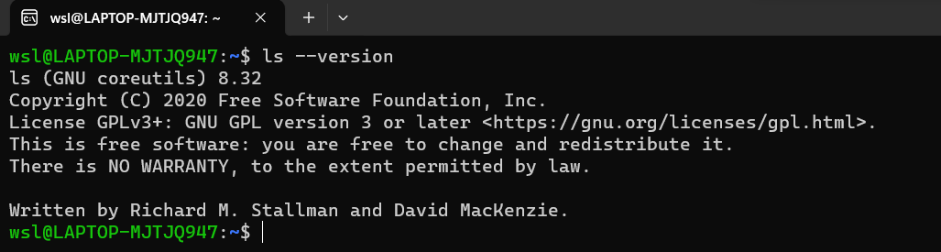

14. Command: ls –i

Interpretation:

List the contents of directory with index numbers

Output:

